Jorge Javier Mejorada Hernández. Tuesday, Junuary 10, 2023.

* WEB FUNDAMENTALS
* WEEK 01.
* **URL:** Uniform Resource Locator.
* **HTML** and **CSS** are front-end languages.
* **Php** and **Python** are examples of back-end languages.
* **Screen readers**
* The **HTML** elements are shown in red with angle brackets **<body>, <h1>, <h2>, <p>** Opening and closing tag.
* **Nesting:** It’s tags inside other tags (**Child tags).**
* **HTML:** Hyper Text Markup Language.
* **HTML:** It’s not a programming language, is a markup language.
* We can write **HTML** code anywhere.
* The first line is a document line declaration **<!DOCTYPE html>**

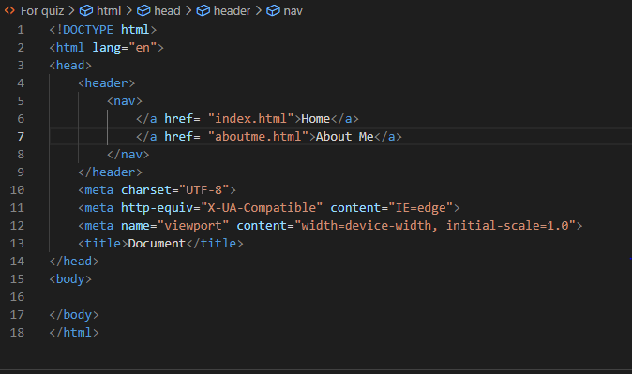

* **HTML:** is always in lowercase.



* This element don’t have an opening and a closing tag.
* Two **attributes** the **SRC (Source) or Alt (Alternative Text).**
* **HTML** handles the structure of the page, and **CSS** handles how it’s presented or how it looks.
* **CSS** is the language used to style an **HTML** document. It describes how the **HTML** should be displayed.
* **C**ascadian

**S**tyle

**S**heets

* You should always keep your **HTML** and **CSS** separated, if possible.
* The **HTML** element is used to tell our **HTML** page which **CSS** file is used to style your page.

You can have multiple **CSS** files affecting one **HTML** page.

**WORKBOOK**

* **WEEK 02: UNDERSTANDING CSS**
* **CSS Intro:** Cascading Style Sheets
* **CSS** stands for cascading style sheets. It is a style sheet language used to layout and style web pages.

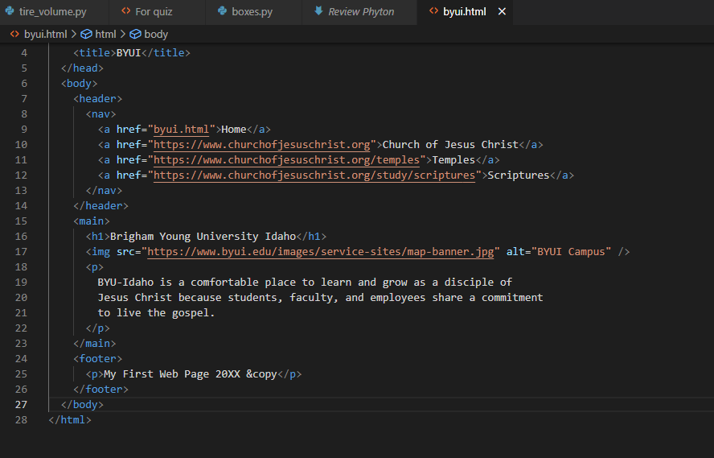

* **HTML** file

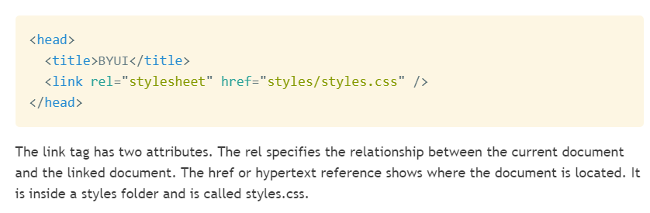

* **This is the first line of the CSS file.**

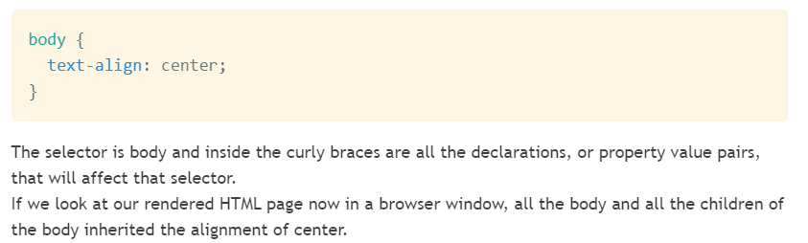

* **Result in the browser window:**

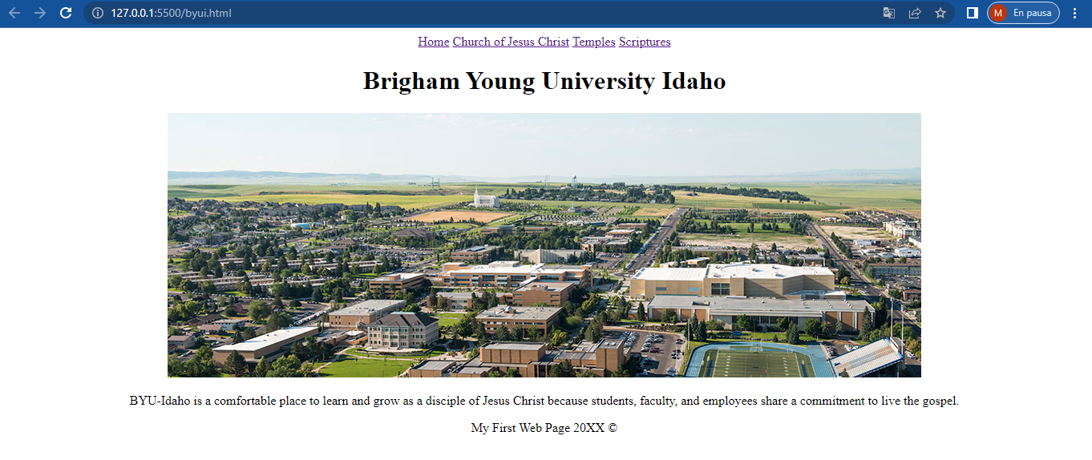

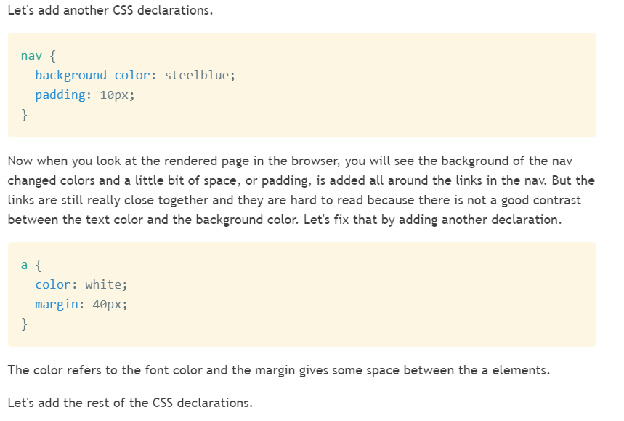

* **Result in the browser window:**

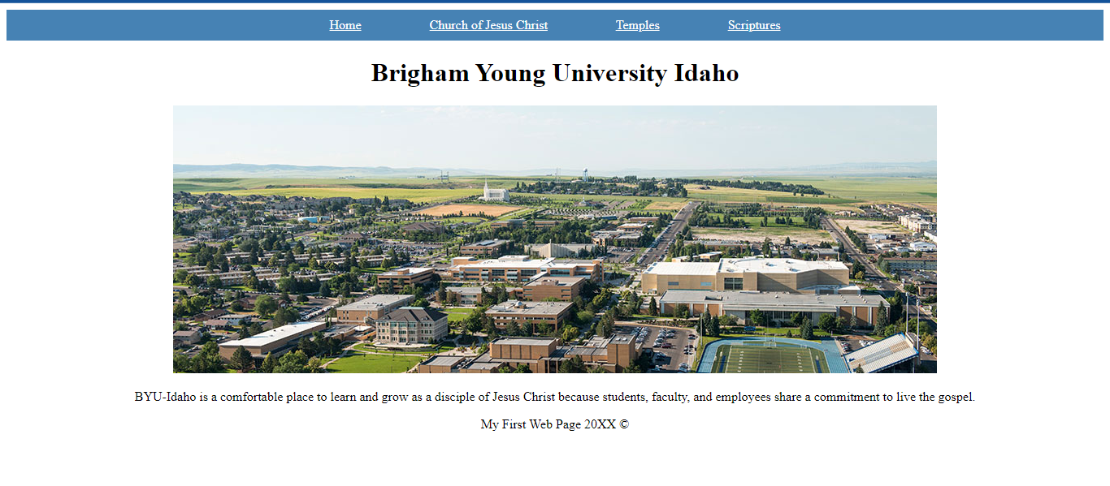

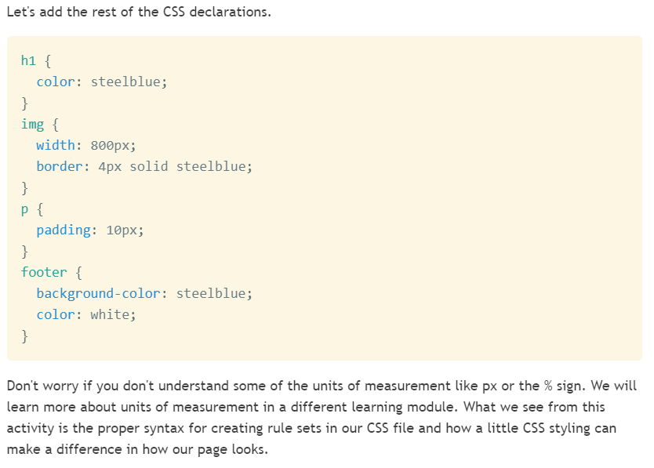

* **Result in the browser window:**

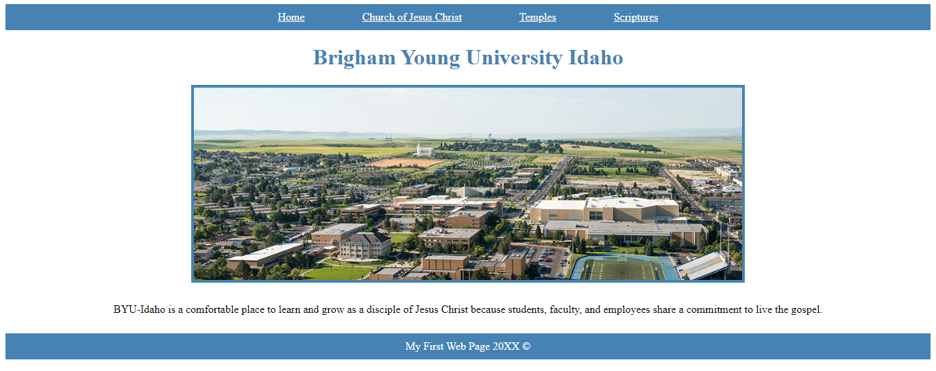

* **WEEK 03: WIREFRAME TO HTML.**
* **Class in HTML:** There are placed inside the beginning tag of the element**: <p class=”anyname”>** This is a wonderful paragraph **</p>** Later when **CSS** is use the ID and Class values can be used to target that element: **.anyname {color: green; }** And the other elements would not be affect.

**Class in HTML Calling the class instead <p> in CSS**

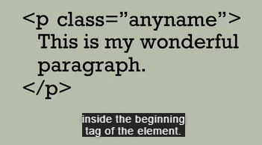 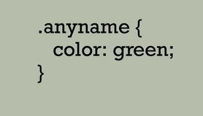

* **‘shaded’** is the class we want to set a background-color, so in CSS we put a dot, then the class and after that we put the **property name** and **the value, don’t foget the brackets.**

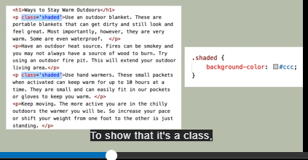

**Result:**

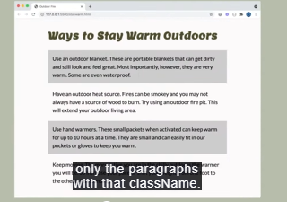

* **ID in HTML** means we are setting apart the elements of our code one by one, and all the ID’s should be different.

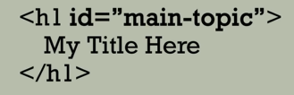 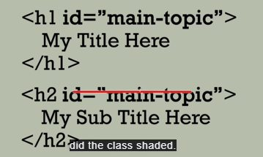

* **To apply it in CSS** we use a # and then the ID name



* **In HTML** you can use more than one **Class** in the same element, example:

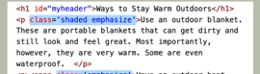

* There we see that the **Class names** are ‘shaded’ and ‘emphasize’, so you can call that <p> element in **CSS** as one or another.
* You can even have an **ID** and a **Class** in a same element and call it when needed.

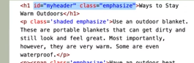

* **W3C Validation** is a great way to debug your HTML file.

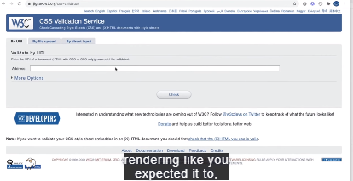

* **Wireframe** anticipates how a web page is going to look like, example:

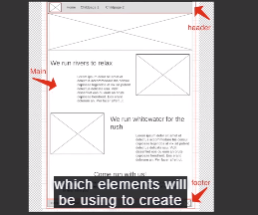

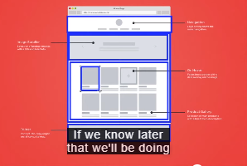

* **Class and ID Selectors**

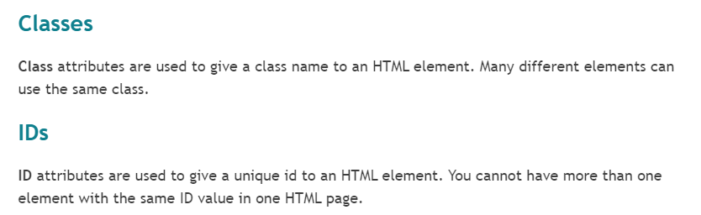

* **Working with Wireframes**

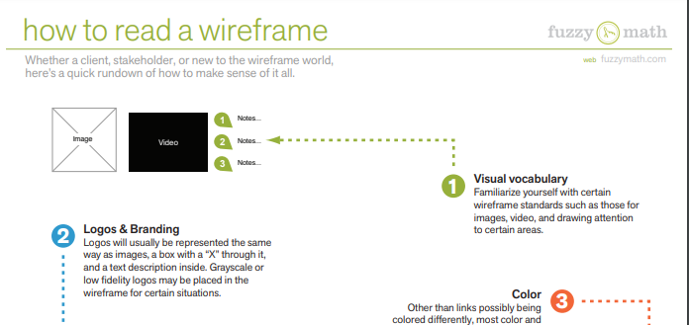

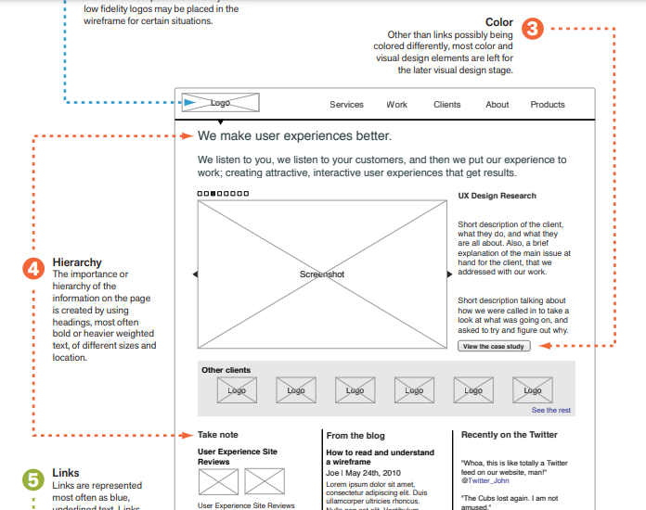

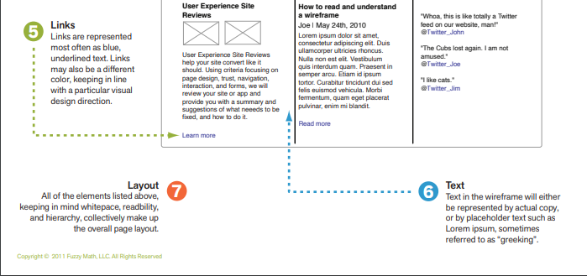

* **IMPORTANT FOR THE WIREFRAME!!!!**

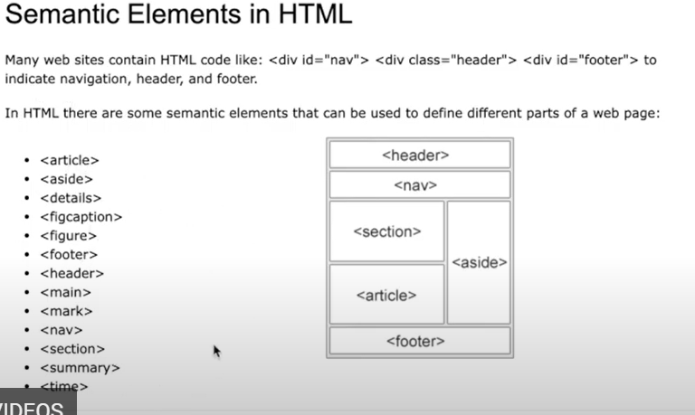

* **Some code HTML for the wireframe:**

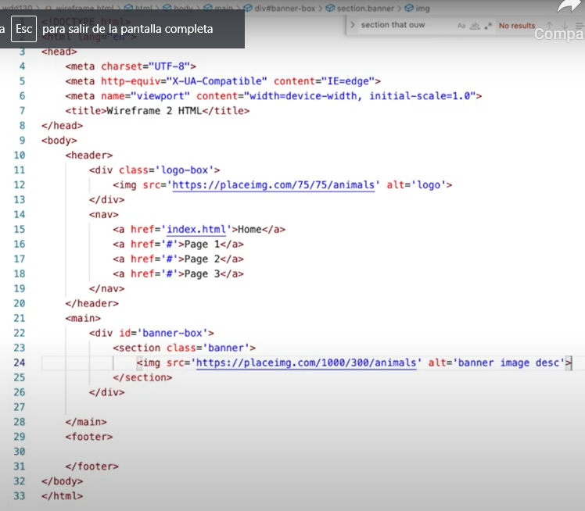

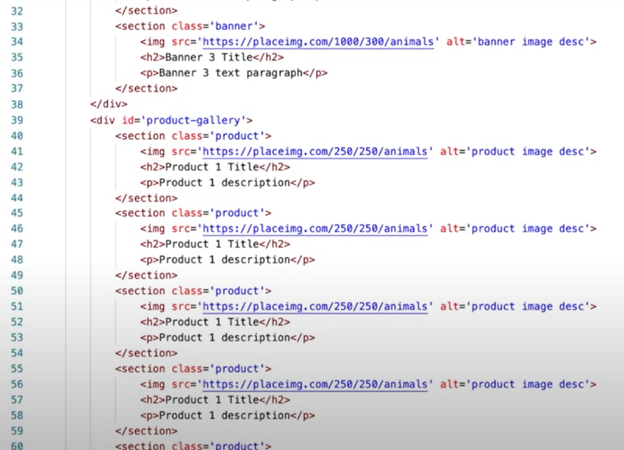

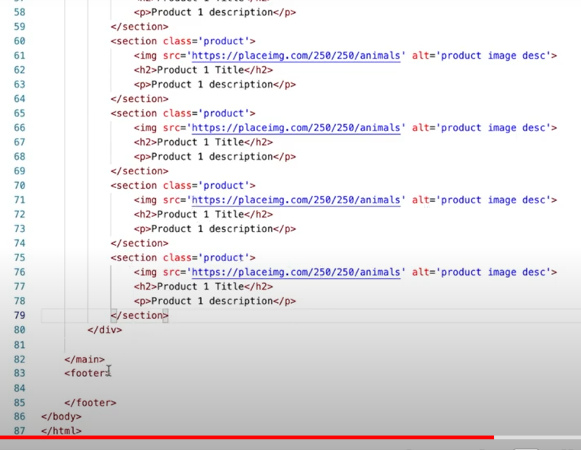

* **ELEMENTS FOR THE HTML CODE:**

**https://www.w3schools.com/html/html5_semantic_elements.asp**

* **Need some placeholder images in HTML if you don't have your images picked out yet?**

[**https://placeimg.com/**](https://placeimg.com/)

* **Troubleshooting.**
* **Validating is easy.** Go to **https://validator.w3.org/,** then enter in the same url that you would submit in iLearn for your site. It will check for any HTML errors and tell you where they are. Don't panic if it comes back with some really high number. One error can often cascade and create many others. I recommend fixing the first, then re-validating until all are gone.
* **Validate your CSS!** There is also a CSS standard, so you can validate that as well to check for errors. The process is similar, you just need to go to a different site. The CSS validator can be found at: **https://jigsaw.w3.org/css-validator/.** Follow the same steps...fix the first error then re-validate until clean.
* BACKEND DEVELOPER: WHAT YOU SHOULD KNOW.
* Some of the languages you should know:

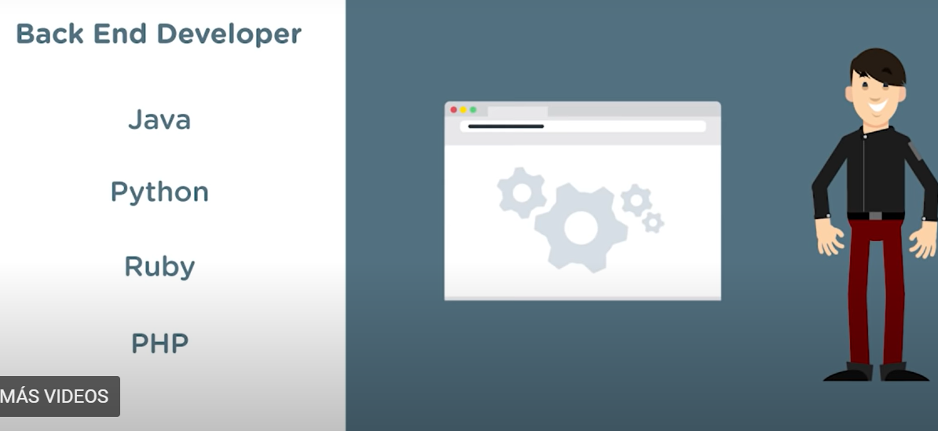

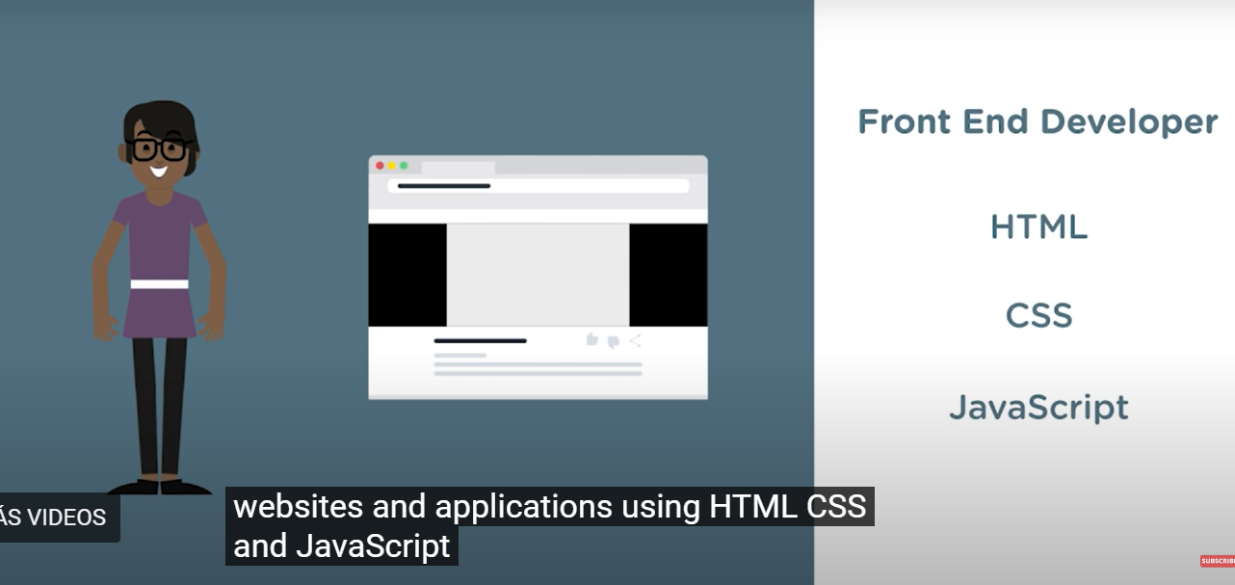

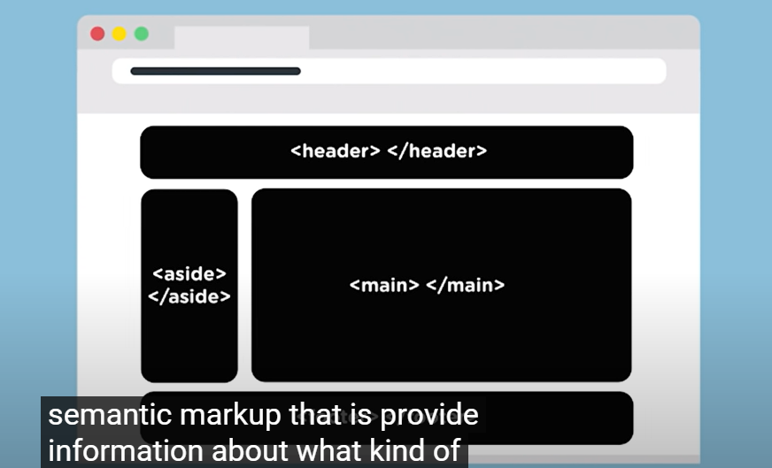

* **For images:**

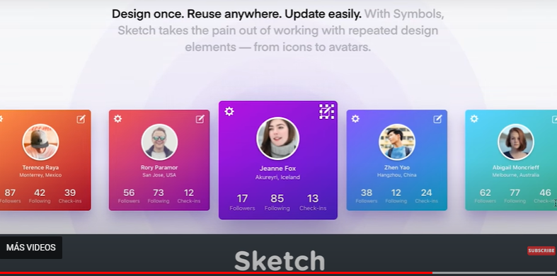

* **For wireframes:**

IMPOURTAN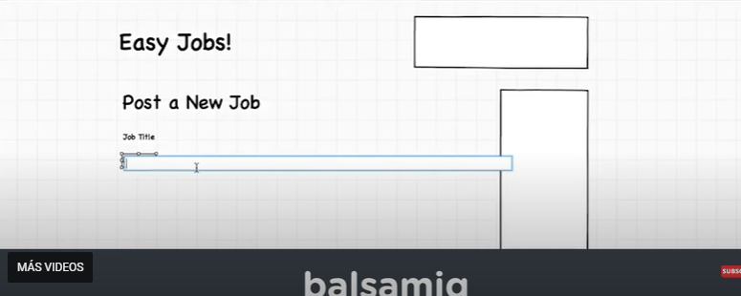

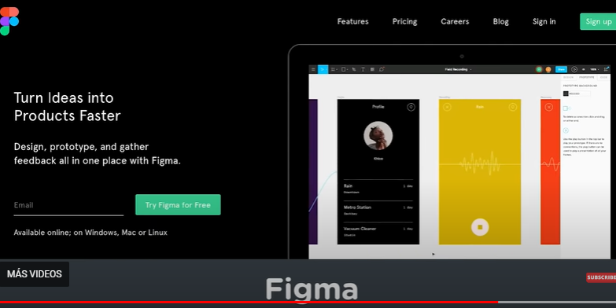

* **IMPORTANT:**

